**TABLES CREATED:**

Hotel table: 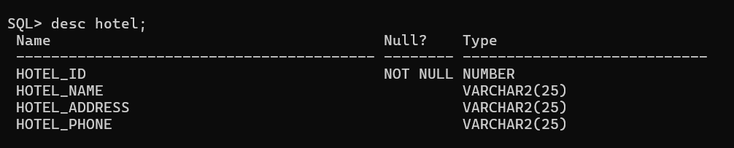

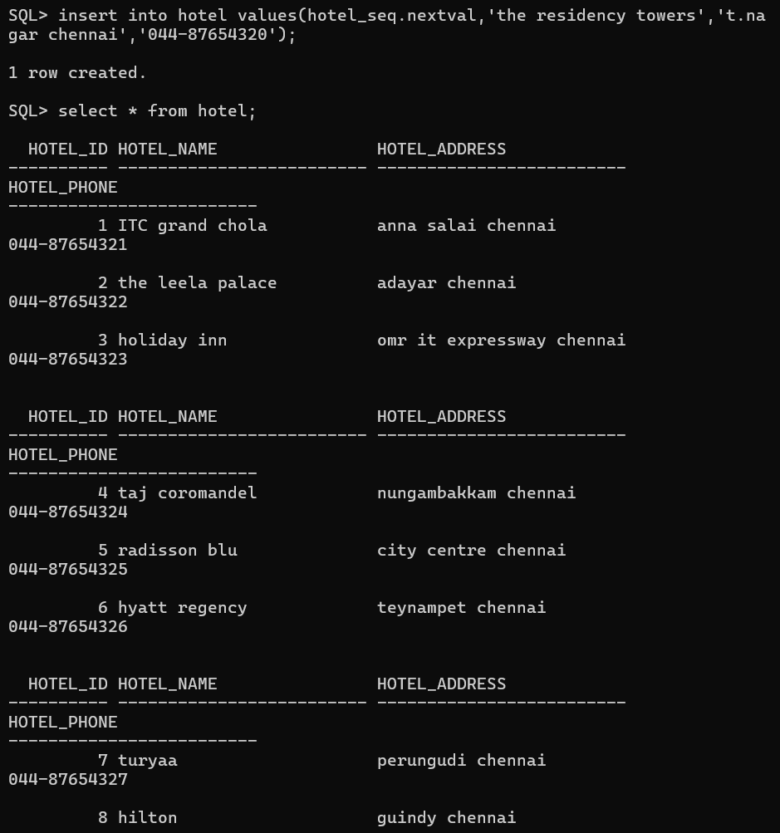

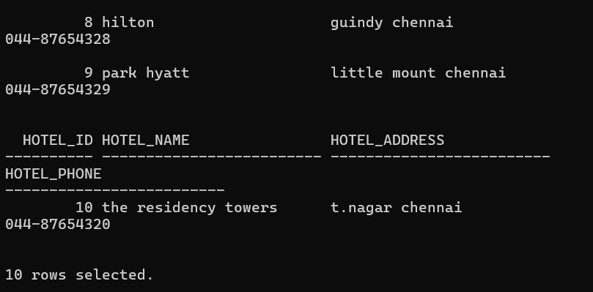

Room table:

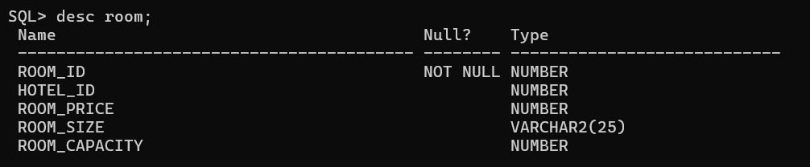

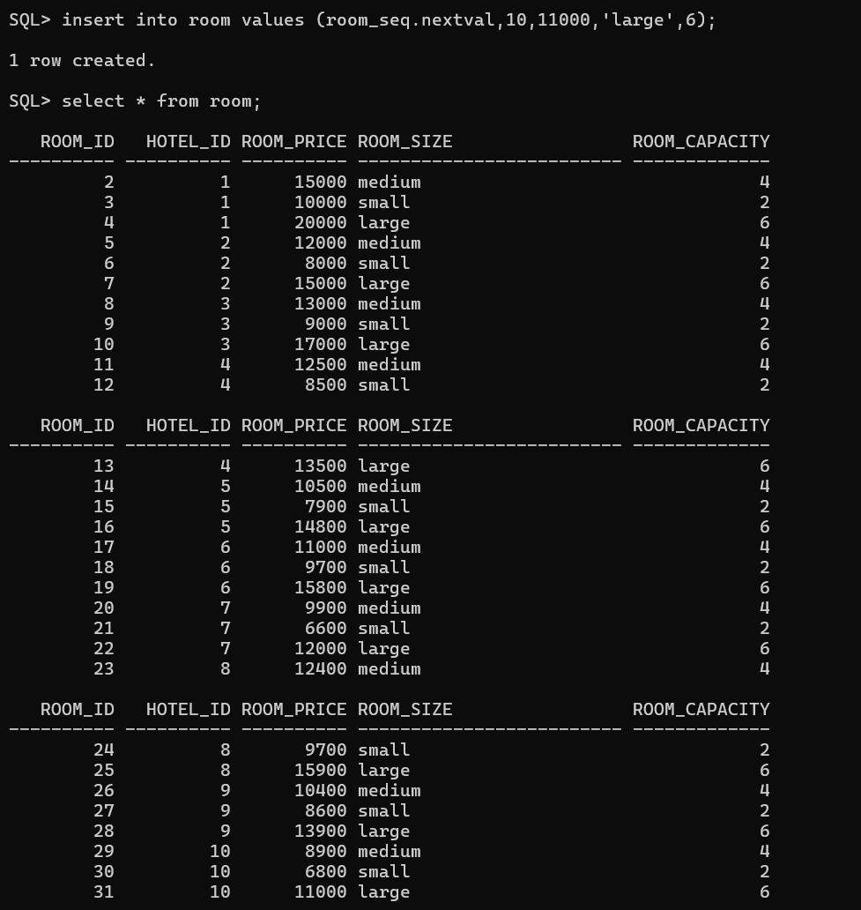

Guest table:

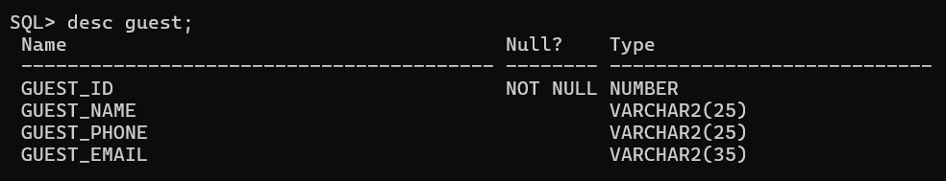

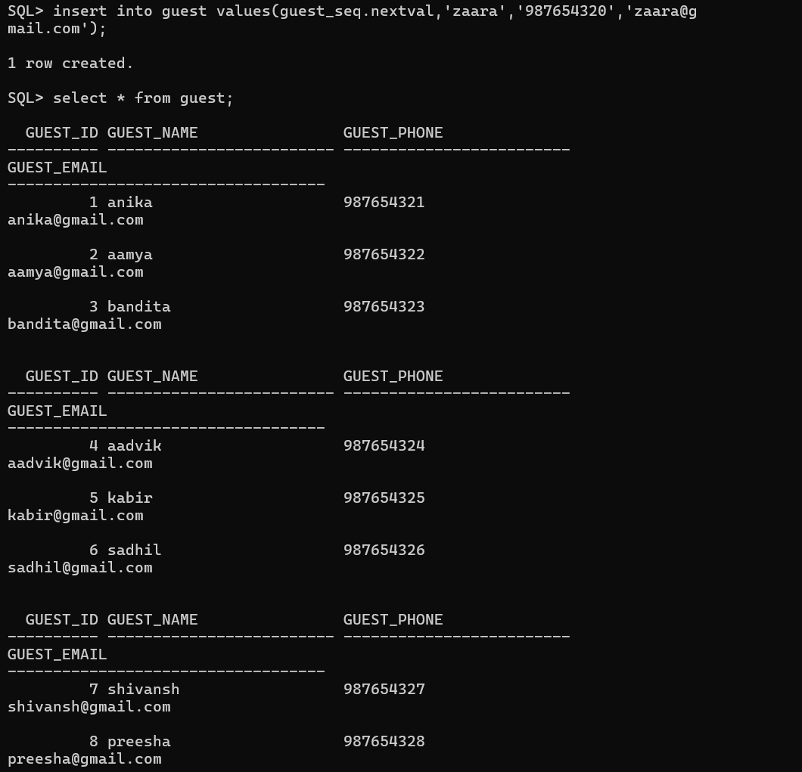

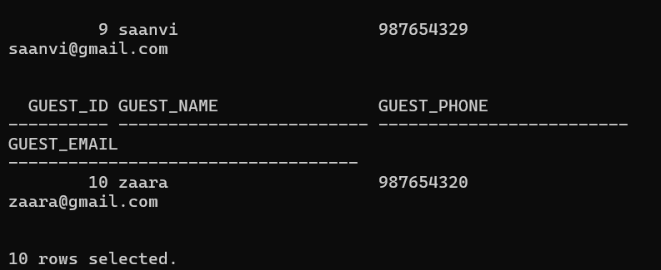

Room reservation table:

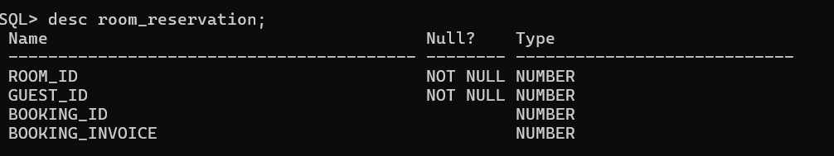

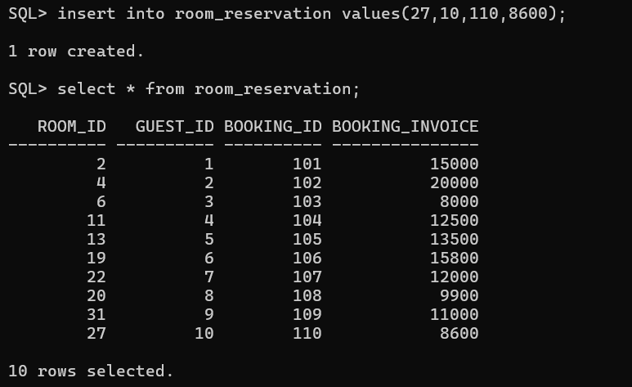

Event table:

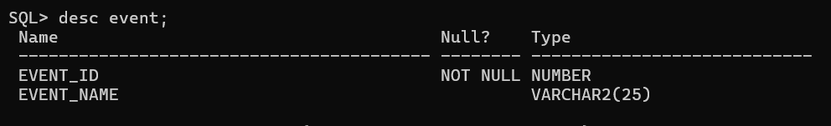

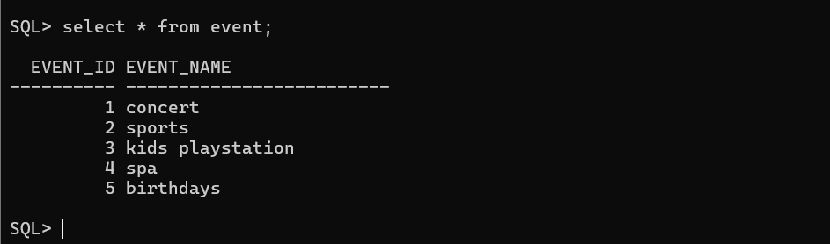

Event in hotel table:

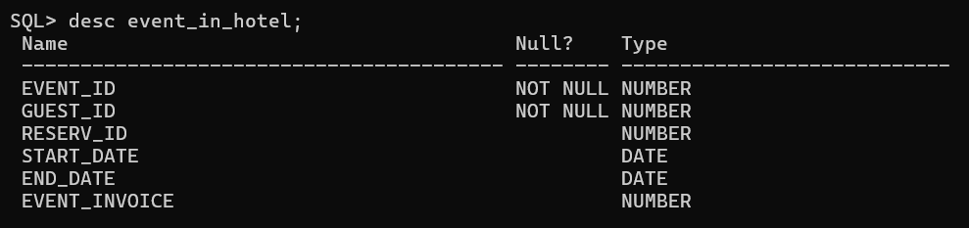

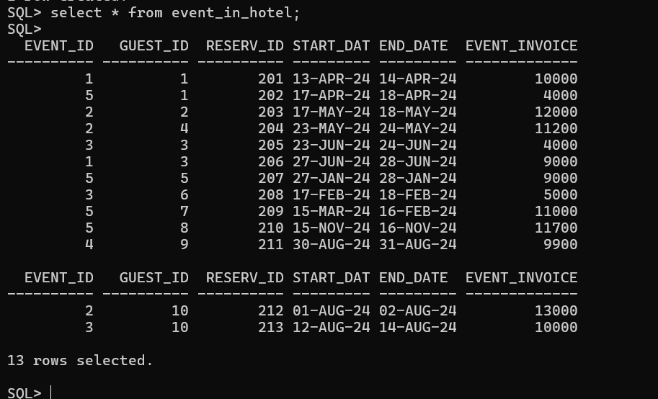

**SQL AND PL/SQL QUERIES ON THE TABLE:**

1.Find hotel:

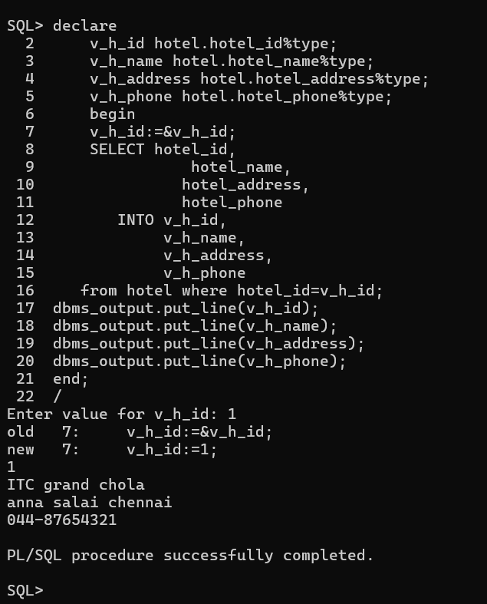

2.Find guest:

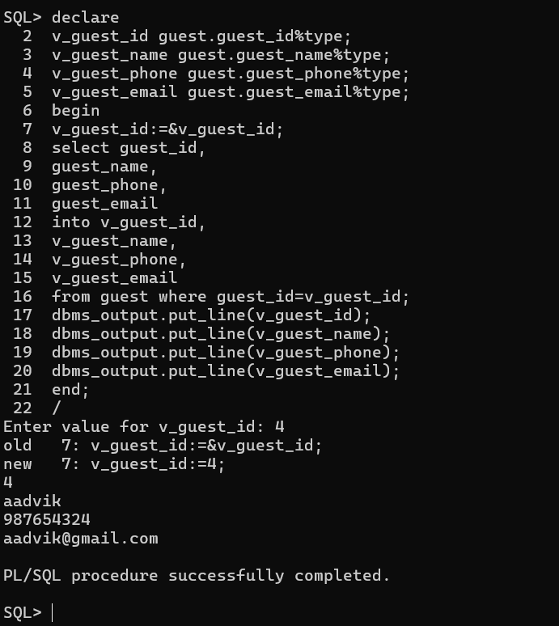

3.Find room:

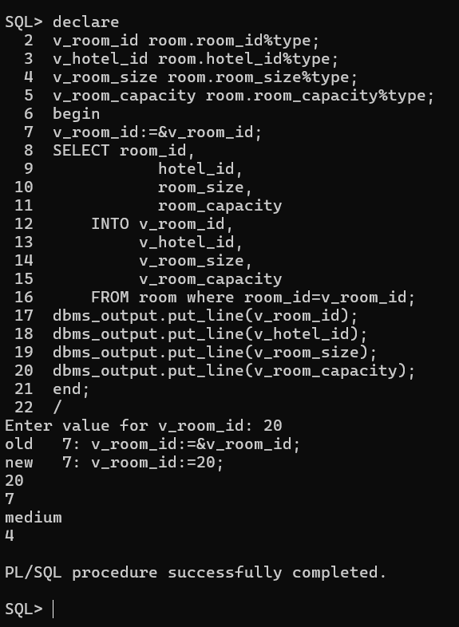

4.Find room reservation:

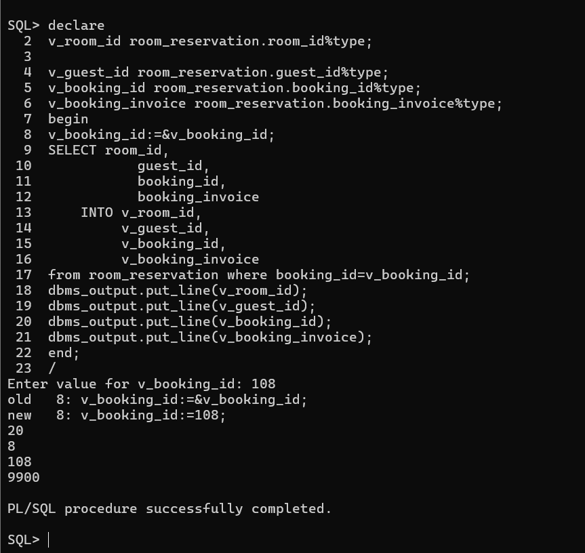

5.Find event:

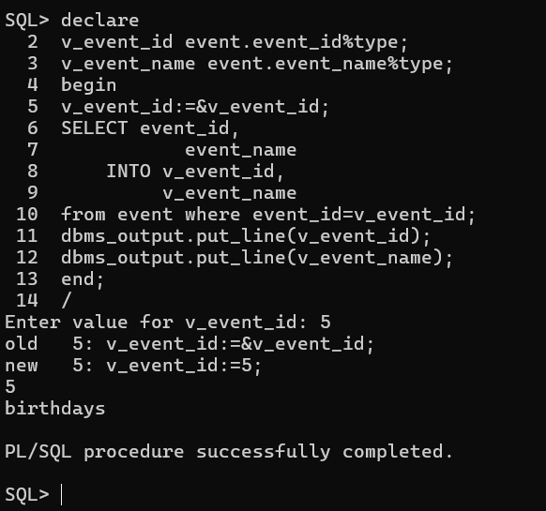

6.Find event in hotel:

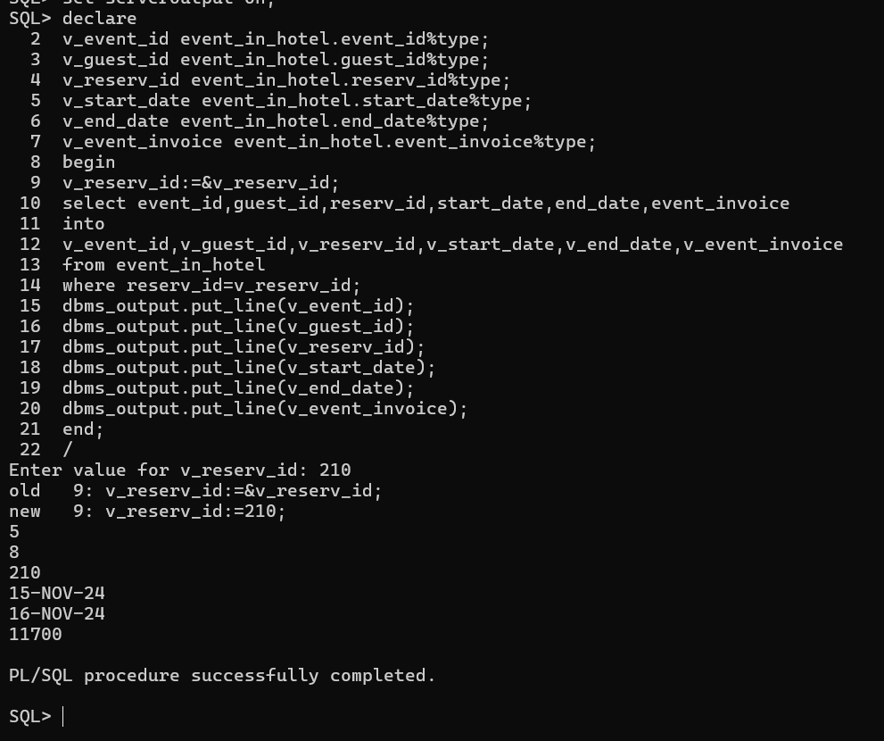

7.Finding the hotel name, id and room id when the price of the room is greater than 15000.

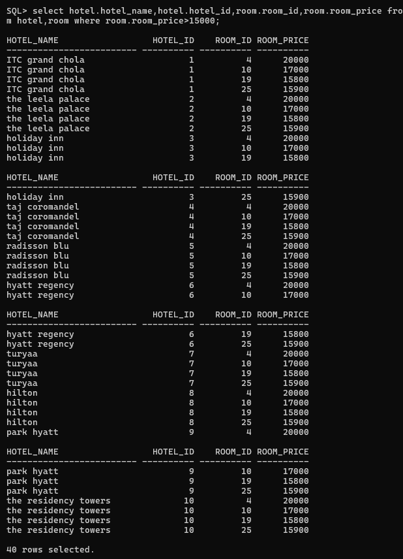

8.Finding the names of the guests who have reserved a room for the invoice of 20000.

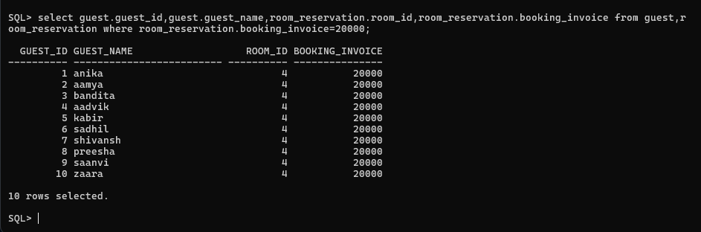

9.(Using Cursors)

Finding the details from the event_in_hotel table, where the event_invoice of the guests is greater than 9000.

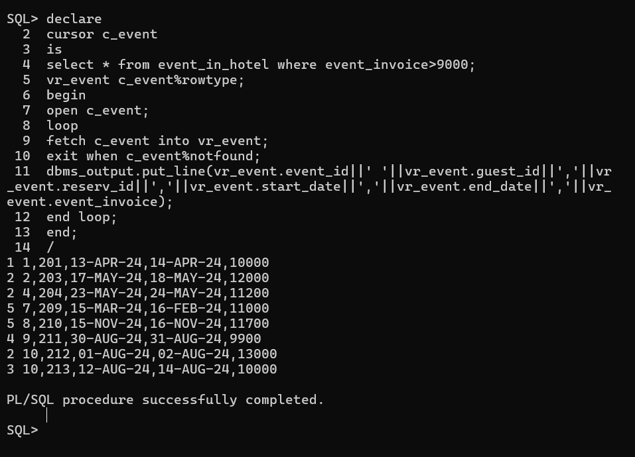

10. Check for the number of rooms that exist with the room size of 2.

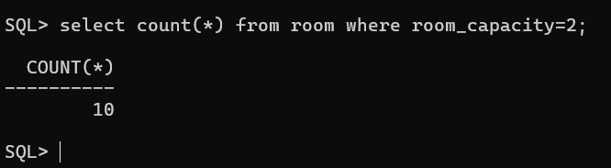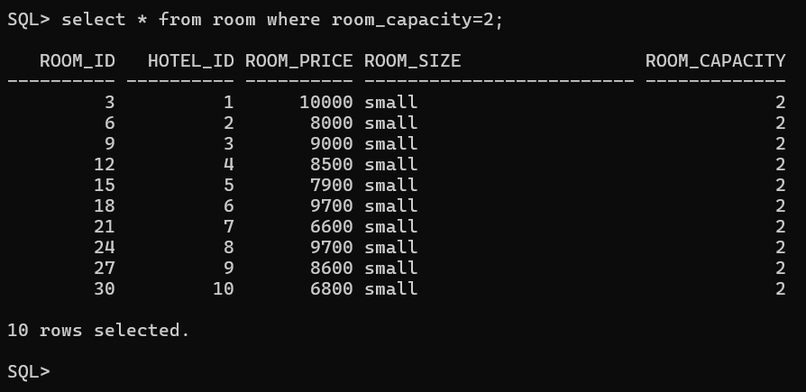

11. Check for room availability with respect to booking_invoice (if booking invoice is 0Rs, then that room is empty).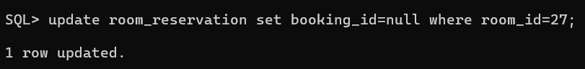

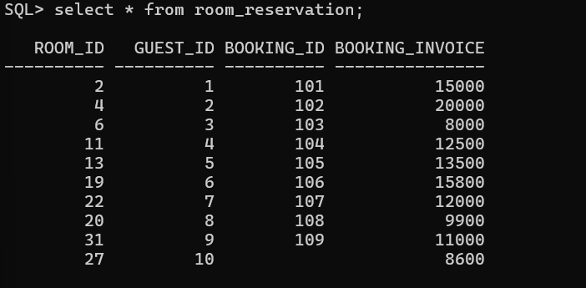

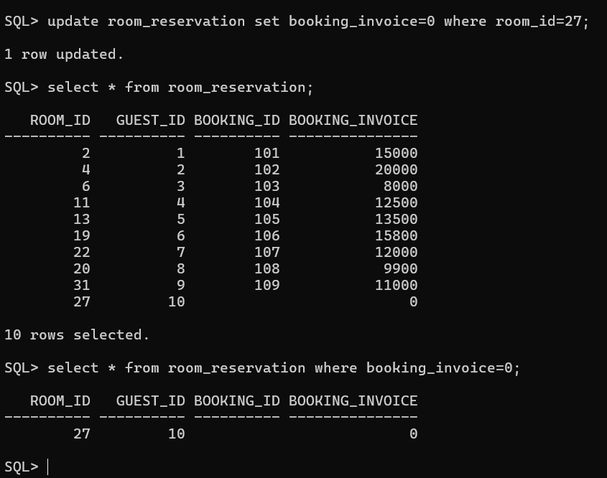

**A DBMS PROJECT BY:**

**PRAVESHIKA M**

**23MIA1044**